WEST VIRGINIA COAL ASSOCIATION
ANNUAL MEMBERSHIP MEETING
August 10-12, 2023

The Greenbrier Resort
White Sulphur Springs,
West Virginia

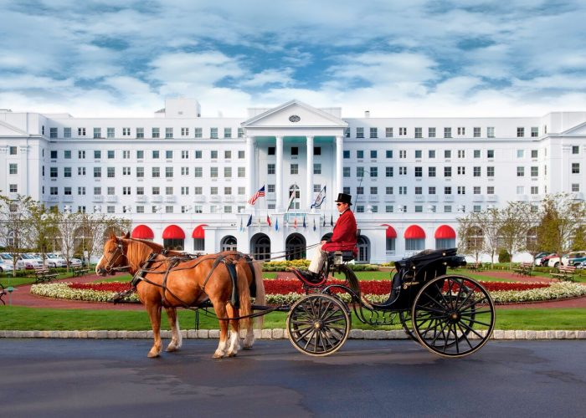

WVCA ANNUAL MEETING

WVCA REGISTRATION
Located in the hotel’s Registration B area
next to The Greenbrier Shoppes

NAME TAGS
Name tags will be collected at Saturday's Brunch and used for door prize drawings.

DINING RESERVATIONS
Thursday evening dining reservations are required for groups and individual parties. They can be made through reservations at the hotel’s front desk.

GOLF
A block of tee times will be held on the Old White Course in the name of the Association for meeting attendees to golf on their own from 11:30 am to 1:30 pm Friday, August 11th.

NON-GOLFERS PROGRAM
We’re working with the Hotel to provide a variety of things to do for meeting attendees on the afternoon of Friday, August 11. Please check on these activities during on-site registration or check-in.

PRIZE DONATIONS

CHAIRMAN’S BRUNCH Sponsored by

Door Prizes
- $100-$500 Gift Card donated by

(Your name here)

Please contact WVCA to donate a prize and be listed in the program.

THURSDAY, August 10, 2023
11:00 am – 2:00 pm
Registration

2:00 pm – 4:00 pm
Board of Directors or Technical Committee Meetings (to be announced)
McKinley Room

6:00 pm – 7:30 pm
Members’ Welcome Reception
Chesapeake Bay Room and Terrace

Dinner on-your-own
Reservations Are Required through the hotel reservation desk

FRIDAY, August 11, 2023

8:00 am – 2:00 pm
Registration

7:30 am – 8:30 am
Continental Breakfast
Crystal Room

8:30 am – 11:00 am
Crystal Room
Membership Meeting

(Program and Speakers to be announced)

11:30 am
Golf Old White Course

1:00 pm
Non-Golfers Program

1:00 pm – 4:00 pm Tennis Club Mixed Doubles - Round Robin

6:00 pm – 9:30 pm
Reception-Dinner
Cameo Ball Room and Terrace

SATURDAY, August 12, 2023
8:00 am – 1:30 pm
Registration

7:30 am – 8:30 am
Continental Breakfast
Crystal Room

8:30 a.m. – 10:30 a.m.
Membership Meeting
Crystal Room

(Program and Speakers tba)

10:45 p.m.
Chairman's Brunch sponsored by
Colonial Hall

(Program and Speakers tba)

SPECIAL THANKS TO:

CHAIRMAN’S BRUNCH SPONSOR

WELCOME RECEPTION SPONSORS

YOUR NAME HERE

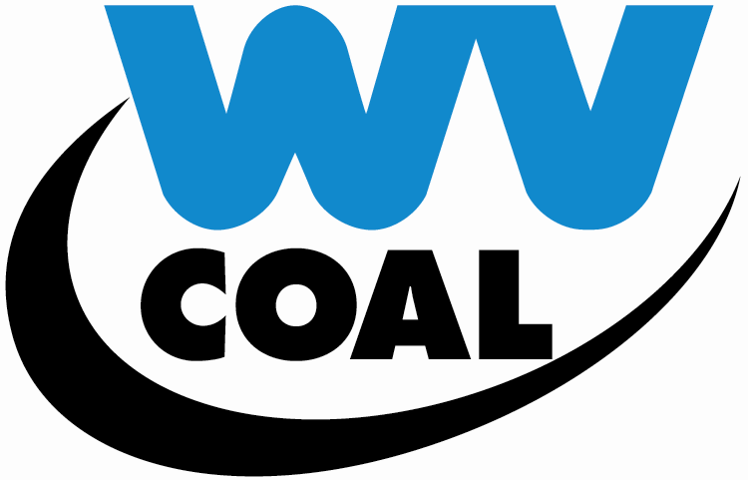

ANNUAL MEMBERSHIP MEETING
August 10-12, 2023

The Greenbrier Resort
White Sulphur Springs,
West Virginia

